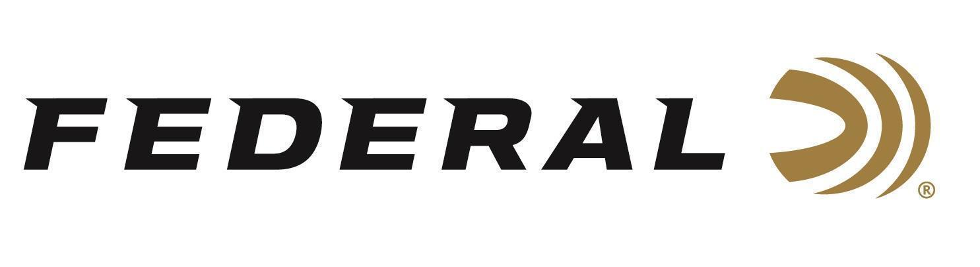

FOR IMMEDIATE RELEASE
Federal’s America 250th Commemorative Target Loads Announced
ANOKA, Minnesota – January 13, 2026 – Federal Ammunition announced its new America 250th commemorative ammunition line will be available soon. Created to honor the country’s 250th birthday, these limited-edition offerings span several of Federal’s most popular target product families, including American Eagle, Top Gun, and Champion. The loads deliver the same reliable accuracy and performance shooters expect, now packaged in collectible designs celebrating America’s 250th anniversary.
“As our country approaches this historic milestone, we wanted to offer shooters something they can enjoy at the range today while also holding onto as a collectible for years to come,” said Federal’s Vice President of Marketing, Jason Nash. “These America 250th loads deliver trusted Federal performance across our most popular target lines, paired with packaging that honors the American spirit and the next 250 years.”
The America 250th line features target-friendly loads across rifle, handgun, rimfire, and shotshell categories, offering a wide range of options for everyday shooting, training, and recreation. Each product is built on proven Federal recipes for consistent performance and dependable function, with special edition packaging that commemorates the nation’s 250th anniversary.
These all-new products, and more, will be on display at the 2026 SHOT Show, January 20–23 at the Venetian Expo and Caesars Forum in Las Vegas, Nevada. Attendees of the show are encouraged to stop by Booth No. 11838 for a first-hand look at these new products and more.

Information about the new products for 2026 can be found on Federal’s brand website soon after the SHOT Show. Sign up to receive exclusive access to online promotions and news via email by visiting Federal Ammunition - Sign Up.

Federal Ammunition products are available at dealers nationwide and online. For more information on all Federal products and to sign up for notifications about new product availability, rebate promotions, and other brand news via email, visit www.federalpremium.com.

Press Release Contact: JJ Reich
Senior Manager – Press Relations
E-mail: media@tkghunt.com

About Federal Ammunition
Federal, headquartered in Anoka, MN, is an ammunition brand of The Kinetic Group, owned by CSG, a globally diversified industrial group based in Prague, Czech Republic. Since 1922, Federal has been a leader in ammunition innovation, delivering high-quality sporting and hunting products to shooters worldwide. With a commitment to conservation and the outdoor community, Federal continues to manufacture industry-leading ammunition that enhances the shooting experience while supporting outdoor traditions.

